Names: _______________________________________________________________________

Date: ______________________________

**Step-By-Step Directions**

1. Click “EASY”
2. Type in your group name.
3. Click “START”
4. Click “NEXT”
5. Look at the left-hand side of the screen with all of the years. Click “NEXT”
6. Click “NEXT”
7. Look at the right-hand side of the screen with the Hat-O-Meter. Click “NEXT”
8. As a class, read all seven hat descriptions. Click “NEXT”
9. Click the “1793” switch on the left side of the screen.
10. Click the red button.
11. As a class, choose an answer.
12. If our answer is correct, click “NEXT QUESTION”
13. If our answer is incorrect, click “CHOOSE AGAIN” and choose another answer.
14. Click the “1808” switch on the left side of the screen.
15. Click the red button.

*Continue going through each year until you get to 2009

*Please go **IN ORDER (from top to bottom)**

*Make sure you are filling out the worksheet as you go

Names: _______________________________________________________________________

Date: ______________________

“The Seven Hat Challenge”



**Example: 1793**

Which president was this?

**George Washington** 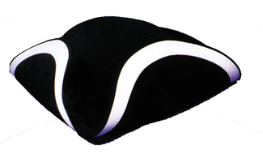

1. What was your first guess? A B C

What was the right answer? **A**  B C

2. What was your first guess? A B C

What was the right answer? A **B** C

**1. ) 1808**

Which president was this? ______________________________________

1. What was your first guess? A B C

What was the right answer? A B C

2. What was your first guess? A B C

What was the right answer? A B C

**2.) 1863**

Which president was this? ______________________________________



1. What was your first guess? A B C

What was the right answer? A B C

2. What was your first guess? A B C

What was the right answer? A B C

**3.) 1944**

Which president was this? ______________________________________

1. What was your first guess? A B C

What was the right answer? A B C

2. What was your first guess? A B C

What was the right answer? A B C

**4.) 1963**  
Which president was this? ______________________________________

1. What was your first guess? A B C

What was the right answer? A B C

2. What was your first guess? A B C

What was the right answer? A B C

**5.) 1992**

Which president was this? ______________________________________



1. What was your first guess? A B C

What was the right answer? A B C

2. What was your first guess? A B C

What was the right answer? A B C

**6.) 2009**

Which president was this? ______________________________________

1. What was your first guess? A B C

What was the right answer? A B C

2. What was your first guess? A B C

What was the right answer? A B C

Directions: Cut out the presidential “hats” below and place them with the correct year they correspond with.

George H.W. Bush Thomas Jefferson

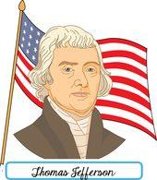

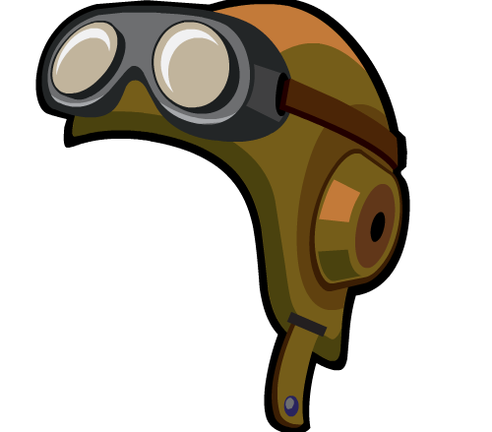

Franklin Roosevelt John F Kennedy



Abraham Lincoln Barack Obama

