Name:_______________ Date:_______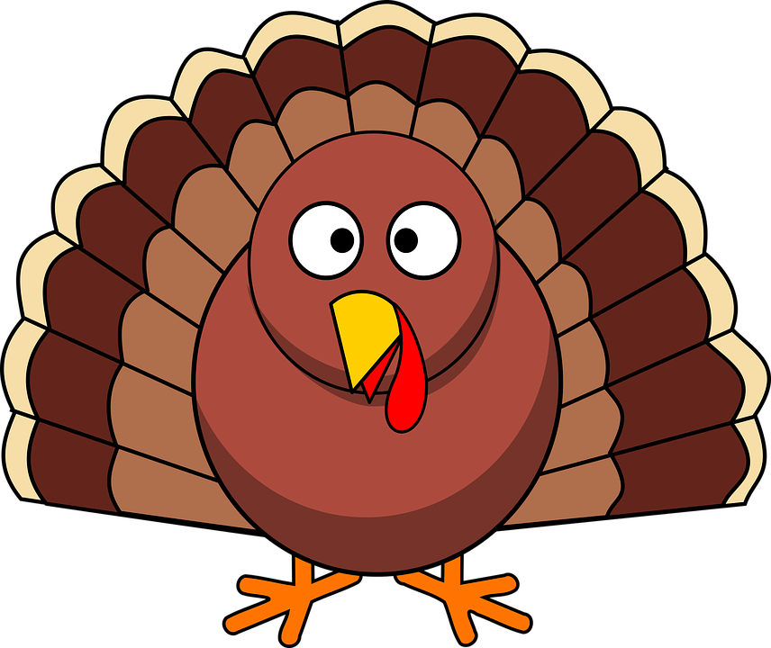

Reimagining Thanksgiving Book Project

Fact Sheet & Vocab List

(Use 5 facts and 3 vocab words from this sheet to help with specific details in your story!)

**Facts**

* The first Thanksgiving took place in the year 1621.
* The first Thanksgiving lasted 3 days long.
* Governor William Bradford was the Pilgrim leader and the person who organized the first Thanksgiving feast.
* There was 50 Pilgrims and 90 Wampanoag Indians at the first Thanksgiving.
* Turkey was not eaten on the first Thanksgiving.
* The menu consisted of : deer, ducks, geese, oysters, lobster, eel, and other types of seafood.
* There were no forks used while eating on the first Thanksgiving. (Only spoons and knives)
* Thanksgiving is celebrated on the fourth Thursday of every November in the United States.
* Benjamin Franklin wanted the Turkey to become the national bird instead of the Bald Eagle.
* Thanksgiving didn’t become a national tradition until Abraham Lincoln declared it in 1863.
* On Thanksgiving in current times Americans eat 46 millions turkeys on this one day.
* 88% of Americans eat turkey on thanksgiving now.

**Vocab Words**

* Turkey
* Pilgrims
* Wampanoag Indians
* Plymouth
* Cornucopia
* Mayflower
* Tradition
* Feast
* Apple Pie
* Delicious
* Family
* Harvest
* Meal
* November
* Settlers
* Vegetables
* Voyage
* Plantation
* Holiday
* Mashed Potatoes
* Memories
* Immigrate
* Appreciation
* Autumn
* Ham
* Family
* Eating
* Dinner
* Corn