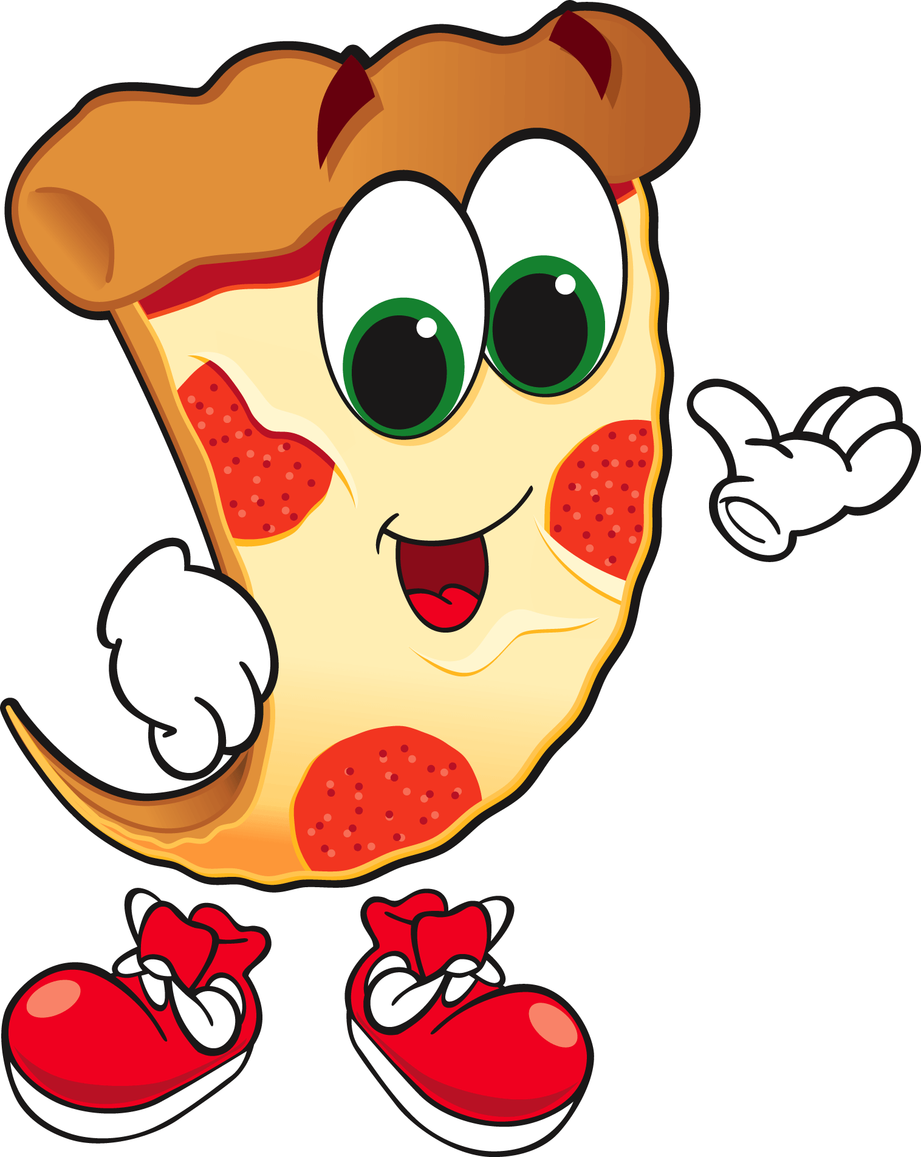
Fractions Made Easy- Working with Pizzas

Working with a partner, work through the Fractions Made Easy game. Make sure to read all the information on the game before you start. After each pizza you and your partner make on the computer, be sure to recreate it here on the worksheet. Answer all questions carefully and work together.

Read through the intro with your partner, click next after each slide, making sure to correctly answer the related question.

- What is the whole circle called?

- What is a numerator? Be sure to use your own words.

- In this example, circle the numerator:
1
4

Explain why you chose that number:

- What is a fraction bar?

- What is the denominator? Use your own words.

- In this example, circle the denominator:
1
4

Explain why you chose that number:

Now that you’re done with the introduction, start playing the game! Be sure to pay attention to the questions on the worksheet while you are making your pizzas! After going through each step, click next when needed.

Pizza Order Number 1:

How many pieces did you choose to cut your pizza into? Were you right? If not, how many pieces was the correct answer?

Can you explain why the pizza has that many pieces?

Cut this pizza up into the same number of pieces:

Now that you have cut this pizza up into the correct amount of slices, color the correct amount of slices that need toppings on it red, to make it like the order you filled in the game. Why did you choose that many slices to have toppings? If you were not correct, what was the correct number of pieces that should have toppings? Why?

Now that you have completed this pizza on the game and on the worksheet, what fraction did you make with your pizzas? Can you tell what each number in the fraction means?

Pizza Order Number 2:
How many pieces did you choose to cut your pizza into? Where you right? If not, how many pieces was the correct answer?

Can you explain why the pizza has that many pieces?

Cut this pizza up into the same number of pieces:

Now that you have cut this pizza up into the correct amount of pieces, color the correct amount of slices that need toppings on it red, to make it like the order you filled in the game. Why did you choose that many slices to have toppings? If you were not correct, what was the correct number of pieces that should have toppings? Why?
Now that you have completed this pizza on the game and on the worksheet, what fraction did you make with your pizzas? Can you tell what each number in the fraction means?

Pizza Order Number 3:

How many pieces did you choose to cut your pizza into? Were you right? If not, how many pieces was the correct answer?

Can you explain why the pizza has that many pieces?

Cut this pizza up into the same number of pieces:

Now that you have cut this pizza up into the correct amount of slices, color the correct amount of slices that need toppings on it purple, to make it like the order you filled in the game. Why did you choose that many slices to have toppings?

Is there anything different you have noticed about this pizza? What can you say about fractions that have the same number for the numerator and denominator?

Pizza Order Number 4:

How many pieces did you choose to cut your pizza into? Were you right? If not, how many pieces was the correct answer?

Can you explain why the pizza has that many pieces?

Cut this pizza up into the same number of pieces:

Now that you have cut this pizza up into the correct amount of slices, color the correct amount of slices that need toppings on it purple, to make it like the order you filled in the game. Why did you choose that many slices to have toppings? If you were not correct, what was the correct number of pieces that should have toppings? Why?

Pizza Order Number 5:

How many pieces did you choose to cut your pizza into? Where you right? If not, how many pieces was the correct answer?

Can you explain why the pizza has that many pieces?

Cut this pizza up into the same number of pieces:

This pizza seems a little different than the others. Now that you have cut this pizza up into the correct amount of slices, color the correct amount of slices that need toppings. Since this pizza has two different toppings, color the amount of slices that need pepperoni red, and the slices that need mushrooms purple. It’s okay if some of the toppings overlap.

From making this pizza, what can you say about fractions that have the same denominator, but different numerators?

Great job making pizza! Now be sure to keep all your ideas about fractions so we can discuss them as a class!

