Science Unit Plan 1
Working with Simple Machines Grades(5-7)
Daniel Dilling
Objective
After this lesson, the student will be able to identify simple machines. The students will be able to identify the function each simple machine in his or her own words. For each simple machine students will be able to identify at least two simple machines.

What this Unit Addresses:

Instructional Techniques:
This unit plan will have kids working together in groups, small experiments and demonstration work.

Instructional Materials:
Computer or computer lab, and worksheets. Scissors
Printouts of different SM
(6 for each)
Tape
Labels
(For each station)
Worksheets: 1,2,3,4.

Theoretical Purpose:

Simple machines are around us in every day life, they make our lives easier when trying to accomplish our goals. Whether it be to lift things up or to help get from one place to another! Try and think of our world without stairs or elevators or even cars! Simple machines are in everything we see and it is important to have an idea about how the world works around you.

Notes:
Lesson Layout:

First class
*****(Teacher Prep Required)*****
*****Materials*****
Scissors
Printouts of different SM
(6 for each)
Tape
Labels
(For each station)
Worksheet #1 + 2

Teacher: Create seven stations based off of the worksheet of simple machines. Stations will include the title of the station, a definition of what SM it is (within understanding for grade level), and several pictures to help students visualize what each SM looks like.

Students: The students will proceed to their seats and will read a question on the board to help them start todays thinking process. The question should be along the lines of “what is a simple machine?” or what simple machines did you use to get here today?” Students may be confused about what a simple machine is but help them into the topic with some conversation about what simple machines are.

Introduction Activity:

Now that students have basic knowledge about what simple machines might be, break the students into groups to being the first activity “I am a simple machine!” Students should move around in groups of 3 or 4 to different stations around the room and take notes on what the different SM (simple machines) are. You can use the handout attached for student guidelines so they know what to look for.

Notes:

I AM A SIMPLE MACHINE

Name: Date: Sec

Instructions: With your group take down the definition of each simple machine and write down two examples for each machine. Try to identify another example of that simple machine that wasn’t shown around the room!

- What is a wheel and axle? What are two examples found at the station? Can you name any other wheel and axles not label at the station?

Answer:

2) What is a Lever? What are two examples found at the station? Can you name any other levers not label at the station?

Answer:

- What is an Inclined Plane? What are two examples found at the station? Can you name any other Inclined Planes not labels at the station?

Answer:

- What is a Pulley? What are two examples found at the station? Can you name any other Pulleys not labeled at the station?

Answer:

I AM A SIMPLE MACHINE
Part Two
Name: Date: Sec

Instructions: With your group take down the definition of each simple machine and write down two examples for each machine. Try to identify another example of that simple machine that wasn’t shown around the room!

- What is a Gear? What are two examples found at the station? Can you name any other Gears not labeled at the station?

Answer:

- What is a Screw? What are two examples found at the station? Can you name any other Screws not labeled at the station?

Answer:

- What is a Wedge? What are two examples found at the station? Can you name any other Screws not labeled at the station?

Answer:

Lesson Layout:

Second class
*****(Teacher Prep Required)*****
*****Materials*****
Access to a Computer Lab
Bookmarked pages
Worksheet #3+4
Teachers: You will need to arrange ahead of time to use your schools computer labs services so be sure to take care of that first. Bookmark pages that are going to be used in class. Handout worksheets in class and explain instructions before you move to the lab.

Bookmark websites:
http://www.msichicago.org/fileadmin/Activities/Games/simple_machines/
http://www.edheads.org/activities/simple-machines/
Modified Lesson Plan: http://www.softschools.com/science/simple_machines/games/

Students: Follow worksheet guidelines and work alone on worksheet. Can ask students next to each other for help with small things. Recommended to ask teacher.

Notes:

Computer Lab Simple Machine Games!!!!
Name: Date: Sec

Instructions: Please open your web browser and go to book marks and select msichicago.org. Play each game and answer the corresponding questions.
Advice: After the game is played the site will give small explanations DO NOT SKIP THEM! Before you can start each game you have to feed the little character!
Please give each game a couple of tries even I you get the correct answers.

- Which Item did you try first and why? Was it an Item that worked? Could there be an item that works better? How much force did you use when climbing the sandwich if any? What is another example of an inclined plane?
Answer:

2) What was used as the fulcrum in this model of a lever? What is another example of a lever that is not commonly thought of that way?

Answer:

3) Which item did you try first? What item worked the best and why? Why do the cookies make it harder to win the game?

Answer:

4) Which pulley system did you think would work the best? What actually worked the best? Why does using more room = less force? What is another example of a pulley that we see a lot?

Answer:
What was your High score for energy?
Computer Lab Simple Machine Games!!!!
Part two
Name: Date: Sec

Instructions: Please open your web browser and go to book marks and select edhead.org. Click start here and go to THE TOOL SHED to learn about compound simple machines! Please print your score card and hand in with this worksheet!

1) What three simple machines are a part of the wheel barrel? Can you name another object that might use some of these simple machines in them too? Explain their uses.

Answers:

2) Can you find and identify the four simple machines in a can opener? ? Can you name another object that might use some of these simple machines in them too? Explain their uses.

Answers:

3) What are the two simple machines in a stapler? Can you name something else on a teacher’s desk that may use simple machines like these?

Answers:

4) What are the four simple machines in a hand drill? Can you name another object that might use some of these simple machines in them too? Explain their uses.

Answers:
Lesson Layout:

Third class
*****(Teacher Prep Required)*****
*****Materials*****
Review Sheet
Station Materials from Day one

Teachers: Using the Stations and pictures from the first lesson, take a picture or two from each group and make them into new groups. Students will be put into groups and have to identify and organize these pictures into groups. Ask probing questions to make sure everyone in the group understands why a certain picture belongs in a certain group. After the group activity Hand out the review sheet (NOT A TEST) to help see if students have grasped the concepts and if further review is necessary.

Students: In groups students will identify and organize different simple machines into the proper categorize and then will go back to their seats to complete their review.

Notes:

Review (Not a Test!)
Name: Date: Sec

Instructions: Fill out this review sheet to the best of your ability without the help of others. This will not be graded as a test but will be graded for completion. This worksheet is completely for you and will help me (the teacher) understand where you are with the concept of simple machines and if you need more help before we move on.

1) Label each simple machine and give a description of what they do:

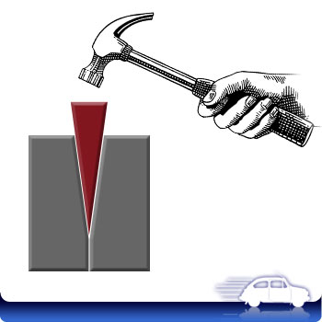
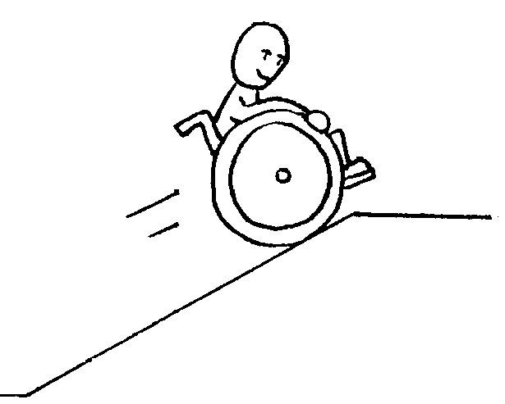
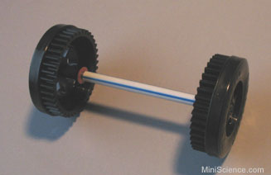
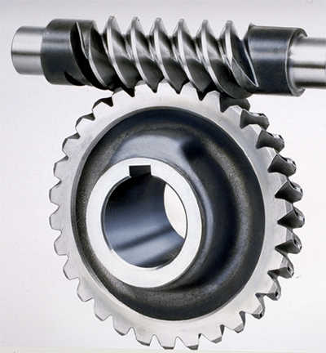
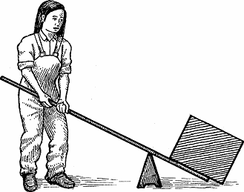

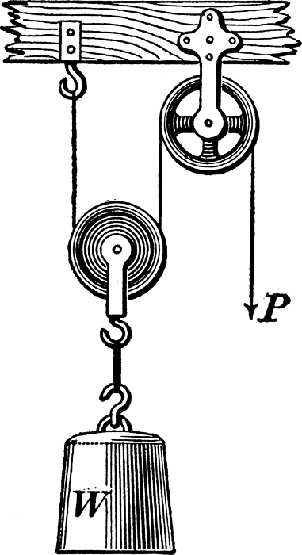

2) Can you name two examples of each simple machine?

Lever:

Gear:

Pulley:

Inclined plane:

Screw:

Wedge:

Wheel and Axle:

Bonus!!!!!!
Can you give two examples of a compound machine(machine with multiple simple machines in it)?

