Name: ________________________________ Date: _______________________________
Caterpillar and Butterfly Anatomy

Use the following website to look up information and label the different parts of the caterpillar: http://www.enchantedlearning.com/subjects/butterfly/anatomy/Caterpillar.shtml
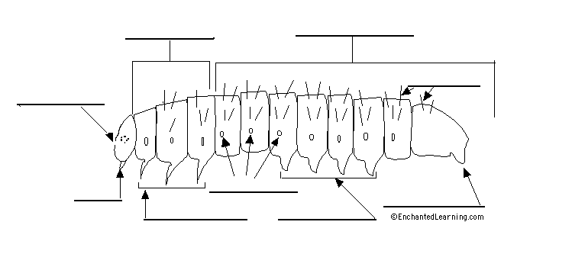

Use the following website to look up information and label the different parts of the butterfly: http://www.shrewsbury-ma.gov/schools/beal/curriculum/butterfly/butterflyinfo.htm

