Name______________________________­___ Date___________________

**Introcuatory Activity- States in the United States**

**Directions**: Label as many states as you can and use the list of states to help you as a giude.

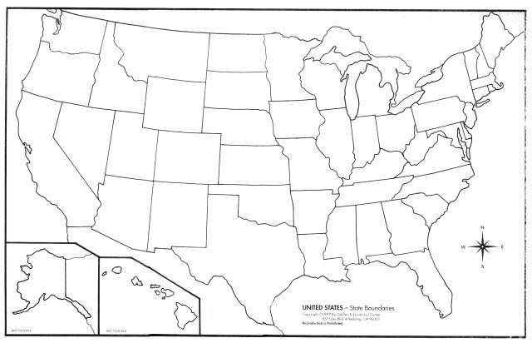

Name___________________________________ Date_______________

**Homework- States and Capitals of the United States**

Directions: Label all the States and Capitals of the United States while using the lists of states and capitals as a guide

