Tour of the World!

Directions: Once you are in groups and have been assigned your continents, look below to find which countries you have to find information on. Fill out the information you find in this packet. Once all the groups are done with their research, you will share your findings with the other groups so that they will be able to fill out the information of your countries. All the countries are included in this packet, and so you must go to the correct pages in order to fill out the information accordingly.

First, color the continents:

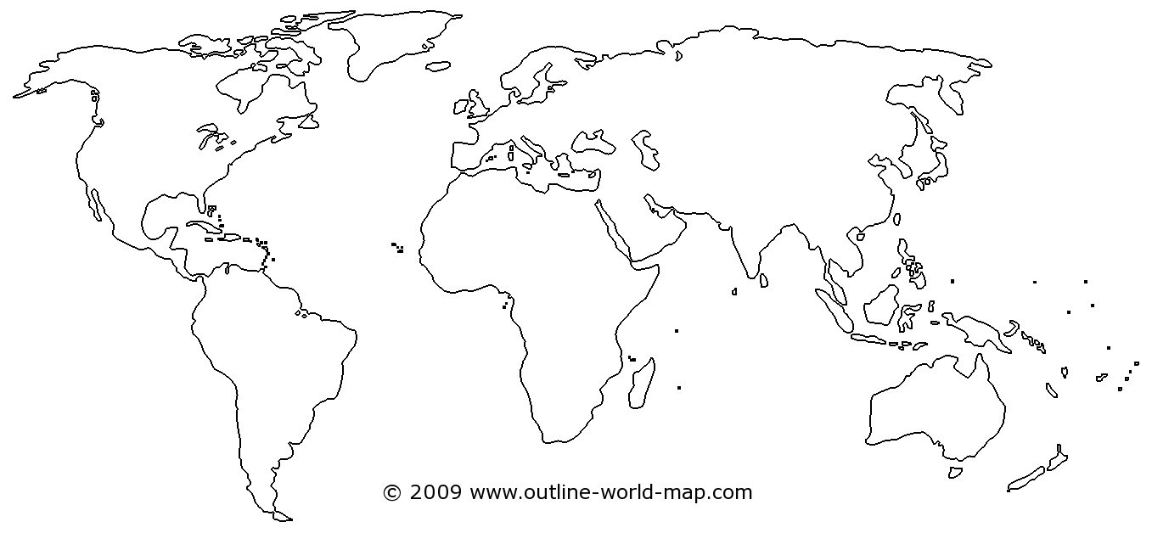

Color North America **RED** Color Asia **ORANGE**

Color Europe **BLUE** Color South America **GREEN**

Color Africa **PURPLE** Color Australia **YELLOW**

Now, color **YOUR CONINENT RED:**



What is the name of your continent? __________________________________

**\*Now go to the section of the packet with you continent and start researching your countries!\***

North America

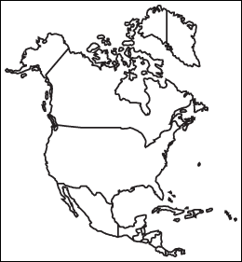

Label and Color The United States of America **RED**

Label and Color Mexico **GREEN**

Label and Color Canada **BLUE**

North America

The United States of America:

Population: _______________________________________________

Capital: _____________________________________________

Popular food dishes (2 or 3):_____________________________________________________________

Currency: ______________________________________________

Flag (color the flag of this country in the box below):

Write two interesting facts that you found out about this country:

1)___________________________________________________________________________________

_____________________________________________________________________________________

2)________________________________________________________________________________________________________________________________________________________________________

Mexico:

Population: _______________________________________________

Capital: _____________________________________________

Popular food dishes (2 or 3):_____________________________________________________________

Currency: ______________________________________________

Flag (color the flag of this country in the box below):

Write two interesting facts that you found out about this country:

1)___________________________________________________________________________________

_____________________________________________________________________________________

2)________________________________________________________________________________________________________________________________________________________________________

Canada:

Population: _______________________________________________

Capital: _____________________________________________

Popular food dishes (2 or 3):_____________________________________________________________

Currency: ______________________________________________

Flag (color the flag of this country in the box below):

Write two interesting facts that you found out about this country:

1)___________________________________________________________________________________

_____________________________________________________________________________________

2)________________________________________________________________________________________________________________________________________________________________________

Europe

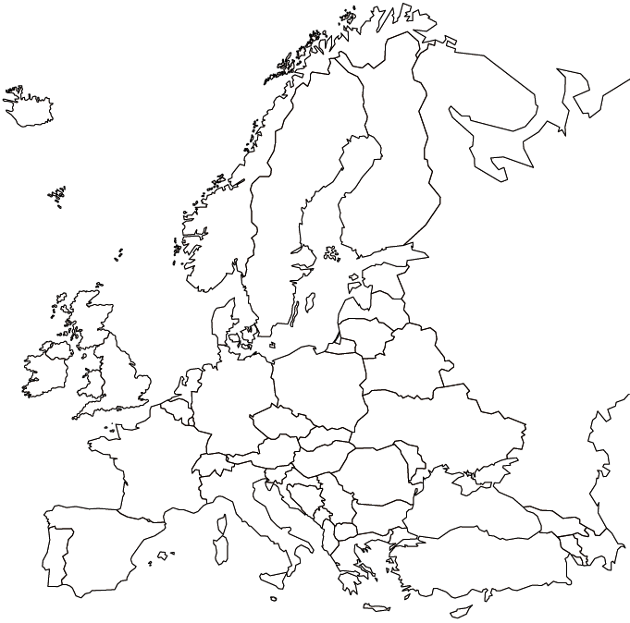

Label and Color Spain **RED**

Label and Color The United Kingdom **GREEN**

Label and Color Germany **BLUE**

Spain:

Population: _______________________________________________

Capital: _____________________________________________

Popular food dishes (2 or 3):_____________________________________________________________

Currency: ______________________________________________

Flag (color the flag of this country in the box below):

Write two interesting facts that you found out about this country:

1)___________________________________________________________________________________

_____________________________________________________________________________________

2)___________________________________________________________________________________

The United Kingdom:

Population: _______________________________________________

Capital: _____________________________________________

Popular food dishes (2 or 3):_____________________________________________________________

Currency: ______________________________________________

Flag (color the flag of this country in the box below):

Write two interesting facts that you found out about this country:

1)___________________________________________________________________________________

_____________________________________________________________________________________

2)___________________________________________________________________________________

_____________________________________________________________________________________

Germany:

Population: _______________________________________________

Capital: _____________________________________________

Popular food dishes (2 or 3):_____________________________________________________________

Currency: ______________________________________________

Flag (color the flag of this country in the box below):

Write two interesting facts that you found out about this country:

1)___________________________________________________________________________________

_____________________________________________________________________________________

2)___________________________________________________________________________________

_____________________________________________________________________________________

Africa

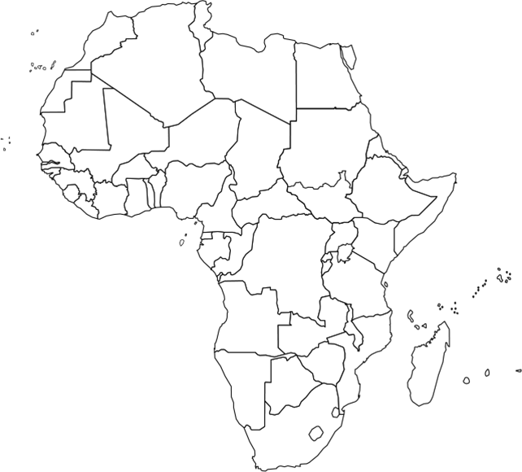

Label and Color Madagascar **RED**

Label and Color Egypt **GREEN**

Label and Color Libya **BLUE**

Madagascar:

Population: _______________________________________________

Capital: _____________________________________________

Popular food dishes (2 or 3):_____________________________________________________________

Currency: ______________________________________________

Flag (color the flag of this country in the box below):

Write two interesting facts that you found out about this country:

1)___________________________________________________________________________________

_____________________________________________________________________________________

2)___________________________________________________________________________________

_____________________________________________________________________________________

Egypt:

Population: _______________________________________________

Capital: _____________________________________________

Popular food dishes (2 or 3):_____________________________________________________________

Currency: ______________________________________________

Flag (color the flag of this country in the box below):

Write two interesting facts that you found out about this country:

1)___________________________________________________________________________________

_____________________________________________________________________________________

2)___________________________________________________________________________________

_____________________________________________________________________________________

Libya:

Population: _______________________________________________

Capital: _____________________________________________

Popular food dishes (2 or 3):_____________________________________________________________

Currency: ______________________________________________

Flag (color the flag of this country in the box below):

Write two interesting facts that you found out about this country:

1)___________________________________________________________________________________

_____________________________________________________________________________________

2)___________________________________________________________________________________

_____________________________________________________________________________________

Asia

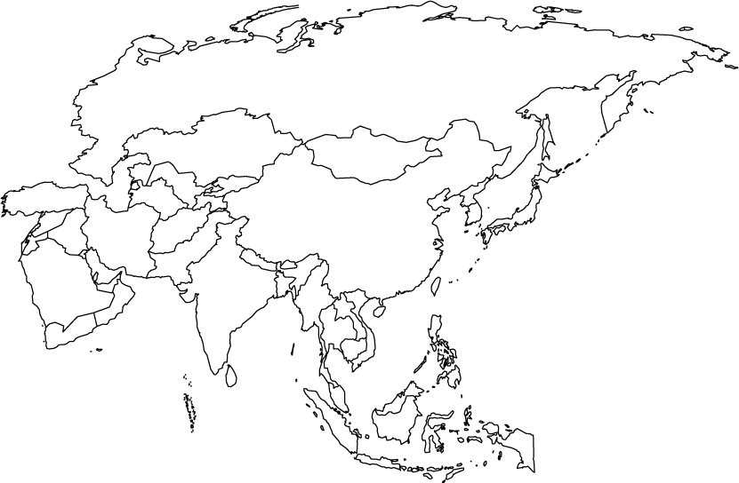

Label and Color China **RED**

Label and Color India **GREEN**

Label and Color Japan **BLUE**

China:

Population: _______________________________________________

Capital: _____________________________________________

Popular food dishes (2 or 3):_____________________________________________________________

Currency: ______________________________________________

Flag (color the flag of this country in the box below):

Write two interesting facts that you found out about this country:

1)___________________________________________________________________________________

_____________________________________________________________________________________

2)___________________________________________________________________________________

_____________________________________________________________________________________

India:

Population: _______________________________________________

Capital: _____________________________________________

Popular food dishes (2 or 3):_____________________________________________________________

Currency: ______________________________________________

Flag (color the flag of this country in the box below):

Write two interesting facts that you found out about this country:

1)___________________________________________________________________________________

_____________________________________________________________________________________

2)___________________________________________________________________________________

_____________________________________________________________________________________

Japan:

Population: _______________________________________________

Capital: _____________________________________________

Popular food dishes (2 or 3):_____________________________________________________________

Currency: ______________________________________________

Flag (color the flag of this country in the box below):

Write two interesting facts that you found out about this country:

1)___________________________________________________________________________________

_____________________________________________________________________________________

2)___________________________________________________________________________________

_____________________________________________________________________________________

South America

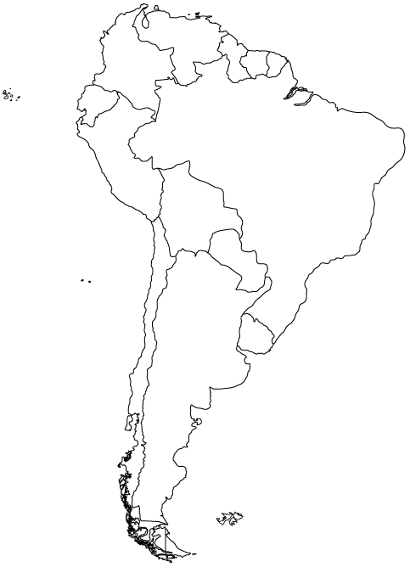

Label and Color Brazil **RED**

Label and Color Chile **GREEN**

Label and Color Argentina **BLUE**

Brazil:

Population: _______________________________________________

Capital: _____________________________________________

Popular food dishes (2 or 3):_____________________________________________________________

Currency: ______________________________________________

Flag (color the flag of this country in the box below):

Write two interesting facts that you found out about this country:

1)___________________________________________________________________________________

_____________________________________________________________________________________

2)___________________________________________________________________________________

_____________________________________________________________________________________

Chile:

Population: _______________________________________________

Capital: _____________________________________________

Popular food dishes (2 or 3):_____________________________________________________________

Currency: ______________________________________________

Flag (color the flag of this country in the box below):

Write two interesting facts that you found out about this country:

1)___________________________________________________________________________________

_____________________________________________________________________________________

2)___________________________________________________________________________________

_____________________________________________________________________________________

Argentina:

Population: _______________________________________________

Capital: _____________________________________________

Popular food dishes (2 or 3):_____________________________________________________________

Currency: ______________________________________________

Flag (color the flag of this country in the box below):

Write two interesting facts that you found out about this country:

1)___________________________________________________________________________________

_____________________________________________________________________________________

2)___________________________________________________________________________________

_____________________________________________________________________________________

Australia

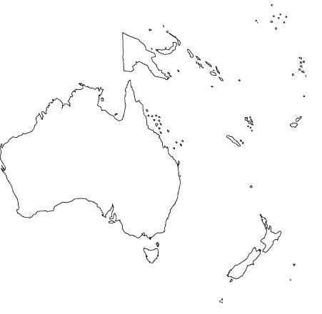

Label and Color Australia **RED**

Do you notice anything different about Australia as compared to the other continents?

__________________________________________________________________________________________________________________________________________________________________________________________________________________________________________

Australia:

Population: _______________________________________________

Capital: _____________________________________________

Popular food dishes (2 or 3):_____________________________________________________________

Currency: ______________________________________________

Flag (color the flag of this country in the box below):

Write two interesting facts that you found out about this country:

1)___________________________________________________________________________________

_____________________________________________________________________________________

2)___________________________________________________________________________________

_____________________________________________________________________________________

Now that the information for your countries are filled out, listen to the other groups as they present the information that they found to the class. You will have a chance afterwards to walk around and talk to the other groups to fill in any information about the other countries that you missed. Once you have all the information for all the countries filled out, compare and contrast the information from your countries to the information you found out about the rest of the countries. Write your ideas in the space provided below, as we are going to share some of these ideas with the class.

____________________________________________________________________________________________________________________________________________________________________________________________________________________________________________________________________________________________________________________________________________________________________________________________________________________________________________________________________________________________________________________________________________________________________________________________________________________________________________________________________________________________________________________________________________________________________________________________________________________________________________________________________________________________________________________________________________________________________________________________________________________________________________________________________________________________________________________________________________________________________________________________________________________________________________________________________________________________________________________________________________________________________________________________________________________________________________________________________________________________________________________________________________________________________________________________________________________________________________________________________________________________________________________________________________________________________