Bridget Nobbs, Erin Crosby

* **Unit Topic or Theme:** The Moon
* **Grade:** 3rd grade

* * * * * * * * * * * * * * * * *

* **Lesson Topic or Theme**: Phases of the Moon
* **Lesson Objectives:**
* Students will be able to understand the eight moon phases.
* Students will be able to understand the basic science of how the moon works.
* **Instructional Technique:** group work and independent work
* **Instructional Materials:** Moon phases song, moon phases website
* **Theoretical Perspective:**
* This lesson will help students understand the difference between night and day. It also helps them understand why the moon changes throughout the year and why it looks different.
* **Procedure:**

A. Introductory Activity: The students will listen to the moon phases song to help draw upon their prior knowledge.

B. Step-by-step: Student will be making their own moon phase puzzles. Students will match the name of the phase to its corresponding shape. Then they will glue it on to its appropriate place on the paper.

C. Closure: Students will take the moon phases quiz.

D. Adaptations for different learners: The introductory activity helps auditory learners by providing content and music to help them learn. The puzzle helps kinesthetic learners by able to manipulate the materials and by being able to see each phase.

* **Evaluation:**

A. How/ when will you determine if you have met your objectives?

* Students will be able to understand the eight moon phases. Students will demonstrate mastery of the content by completing the puzzles with 70% accuracy or higher and by completing the quiz on the website.
* Students will be able to understand the basic science of how the moon works. Students will demonstrate their understanding by completing all of the activities and be able to discuss the concepts of moon phases and the science behind it in teacher led discussions.

B. Concerns or questions you have about teaching this lesson?

The website does not have a grading system so the teacher will not be able to see how many tries it takes for the students to complete each question.

Example of finished assignment

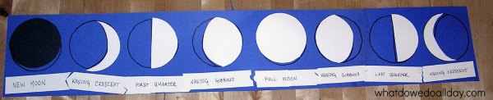

Sources:

<https://www.whatdowedoallday.com/>

<https://www.youtube.com/watch?v=HkvlrWpsnuQ>