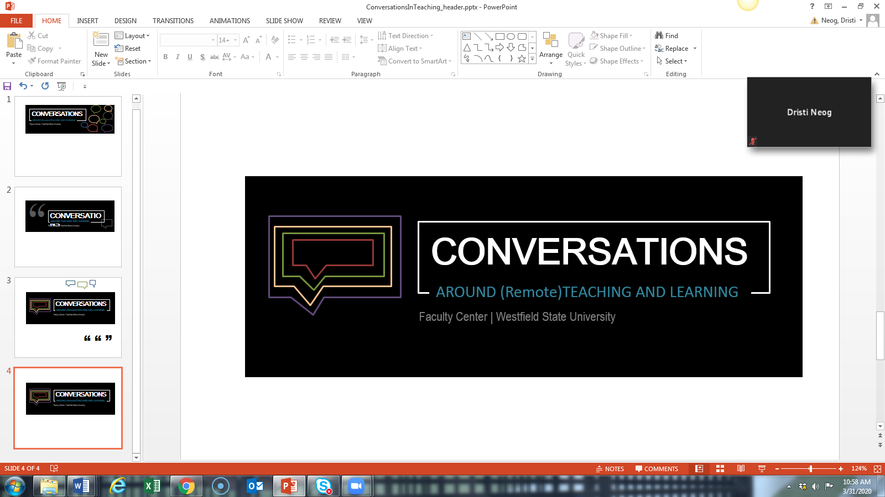

**Supporting your students during the Coronavirus Pandemic**

**Notes from zoom meeting on the 7th of April 2020**

**The problems; Our students have reported that they are facing the following problems:**

Working full-time or lost jobs

We’ve heard stories of students losing their parents or family members being sick

A number of family members have become sick and some of our students are taking care of them.

Issues faced by foster kids

Socially disconnected youth

Not having a space to work- displaced students , sleeping on sofas and with friends, atmospheres not conducive to concentration and working without distractions

Some don’t have access to technology or printers, sometimes have to work from phones

This requires that students find a new way to learn; it is hard to read everything on screen, esp hard for students with concussions, migraines, sitting for extended periods of time)

Students are in difficult family situations

Sometimes students don’t know how to articulate what they need or feel uncomfortable doing so

30% of students are receiving pell grants

For some students (especially students who are multilingual -the work has become so laborious because suddenly the work requires much more reading and writing (discussion board posts, papers instead of tests).

Students who are used to going to therapy on campus might not be able to at home because of lack of privacy or acceptance of therapy in the home (we have heard of students have session in cars)

Students are being called into active duty for national guard

Students are underusing services including the RWC, the Counseling Center, and tutoring services

**What we can do:**

Call or text the students who are not responding via email, showing up or logging in: the phone numbers are available on WSU 360

Refer students to the Counseling Center; they have appointments available. Counselling center working via a HIPPA platform, and through calls. They are also offering relaxation coaching and virtual outreach on grief and anxiety, Virtual fresh check day is on April 23rd,

Refer students to the RWC; there are plenty of appointments available

Notify the students program advisor, coach, or Nicky West, either through WSU 360 or by email if you have not seen a student or if you are otherwise concerned about a student.

To support students’ navigation on PLATO, anyone can get permission from an instructor to become a teacher assistant in a PLATO class. Academic support program advisors might request this from instructors so they can log into Plato with their students to help them figure out what they need to do.

Provide students with checklists that look the same each week.

Provide students extended time on assignments - many students need or want grades for their classes and do not want the pass/fail option.

Use tokens system -example 3 tokens till the end of the semester- to allow for flexibility in deadlines

Do not grade down for grammar, spelling, sentences level issues

If possible offer students an opportunity to connect on a conferencing platform (Zoom or Plato) as a class (don’t penalize students who can’t come) or one-on-one or small groups (break out sessions work really well because it gives students an opportunity to talk one another informally without you there)

Talk about mental health with students

Students who have needs can apply for financial support (look out for email from Erica Broman Owls helping Owls) . There is an Student Emergency fund – The details are in the email sent out by Erica Browman on the 8th of April , subject ‘Owls helping Owls student emergency fund’.

 The application link is  [westfield.ma.edu/OwlsHelpingOwls](http://www.westfield.ma.edu/OwlsHelpingOwls).

 You can reach out to Jen Propp (Social Work) at [jpropp@westfield.ma.edu](mailto:jpropp@westfield.ma.edu) or Marjorie Rodriguez (TRIO) at [mrodriguez@westfield.ma.edu](mailto:mrodriguez@westfield.ma.edu) to discuss your concerns about a student.

Food pantry can also be accessed

Avoid using Lockdown online exam software - it adds more stress for the student, and restricts use of certain assistive software. Nursing is using Zoom to monitor exams.

Banacos exam room staff is available to proctor exams virtually for students with disabilities.

Let students know what their average is now so that they can decide if they want to take the class pass/fail or withdraw or keep with it.

If students are having difficulty keeping up with the reading, suggest that they use a screen reading software available in Adobe, Microsoft Word and other software under accessibility normally. They can contact Banacos with questions, banacos@westfield.ma.edu..

If students are having difficulty keeping up with writing, they might want to speak their responses, comments or papers into their phone or other voice recognition software and then clean it up before sending it.

Use CURCA’s assistance as an opportunity to document their academic growth

Other resources include [Planning toolkit](http://www.westfield.ma.edu/academics/banacos-academic-center/academic-strategies#toolkit), available on the [Academic Strategies](http://www.westfield.ma.edu/academics/banacos-academic-center/academic-strategies) website, link is

<http://www.westfield.ma.edu/academics/banacos-academic-center/academic-strategies#toolkit>